Blandford St Mary Parish Council
Minutes of the monthly meeting of the Parish Council which will take place at The Brewery Hall in Hall & Woodhouse Visitor Centre, Bournemouth Road, Blandford St Mary
Minutes are not verbatim
Wednesday the 2nd of September 2026 at 7pm

Present: Vice Chairman –Cllr J Dallison, Cllr M Dallison, Cllr T Coats, Cllr N Russell
In attendance: Mrs N Phillips (Parish Clerk/RFO), There were 6 members of the public present.
At this point, the Clerk reported that Cllr I Mackay is not well, and the Parish Council wish him a speedy recovery.
Public Consultation- the following matters were raised:
A member of the public expressed his concern that there has not been any works started on the Village Hall in August. It was also noted that the signs around the hall are no longer there. Cllr J Dallison will arrange for the signs to be put back up. This will be discussed under agenda item 4.
Concerns were also raised over the proposed boundary changes for Parish and Town Councils. Dorset Councillor Barrie Cooper will discuss this in more detail under agenda item 7.

32/26. To receive and accept apologies of absence, Declaration of interest and Dispensations.
Cllr I Mackay sent his apologies.

33/26. Co-option for new Councillor
Mr Mark Aldis expressed his interest in joining the Parish Council but was unable to attend this evenings meeting.
Mr Clive Hobbs requested that he is co-opted on as Councillor for Blandford St Mary Parish Council. Cllr T Coats proposed Mr Clive Hobbs is co-opted on as Councillor, this was seconded by Cllr M Dallison, all in favour.
RESOLVED: Mr Clive Hobbs is co-opted on as Councillor for Blandford St Mary Parish Council. (33.26 – New Councillor)

34/26. Approve minutes of the meeting held on the 1st of July 2026
The Minutes of meeting, held on the 1st of Julu 2026 were tabled and ratified.
Items agreed to be discussed from the last meeting and matters arising:
- A public meeting was held on the 29th of July 2026 to report the financial position of the Village Hall project and details of the design. The result from the public meeting was positive for the Parish Council to continue to work on obtaining the extra funds required to complete the project and agreed the amended plans for the hall.
- The Clerk confirmed that the developer is waiting for Dorset Council, building regulations department to approve the amended set up for the toilets before the frame for the hall can be ordered, this is holding up the project slightly.
- The Clerk asked for Councillors to approve Mr Mark Aldis to act as an unpaid officer on behalf of the Parish Council for the Village Hall project.
- Cllr T Coats reported that the Allotment Association have all plots being managed and have a few people on the waiting list. It was also reported that the association have used section 106 funds, that have been allocated to them, for providing 3 new water troughs and to provide an improved area for chippings and manure. The AGM for the association will be held on the 29th of September 2026.
- A member of the public had asked why the Parish Council minutes are not in the Three Village News Letter. The Clerk confirmed that bullet points will be sent to them for publication after each meeting.
- Cllr T Coats reported that the footpath from the Meadows to the blue bridge is in poor condition and the road sign for Fairmile is missing. The Clerk will report both matters to Dorset Council for their action.
Action – Clerk
- Cllr M Dallison reported that the basketball court will have lines painted on the court in due course. The Parish Council are waiting for a quote to repair/upgrade the fencing around the play area. New signs are needed for around the play area and recreation ground. The Clerk will visit the site and look at the signs that need to be replaced. One of the posts with a sign on has been pushed over. The Clerk will ask Ministry of Play to re-install the post. Action - Clerk

35/26.Planning
P/VOC/2026/04285 – Lot 2 Blandford Brewery amend approved plans – duly noted

36/26. Finance
To ratify payments for July 2026 that had been approved via email and agree the payments for August 2026 and the Bank Reconciliation- The Clerk had circulated the payment schedules and bank reconciliation for July and August 2026. Cllr J Dallison proposed the payment for August to be paid, this was seconded by Cllr M Dallison, all in favour. The details of the payments will be shown below:
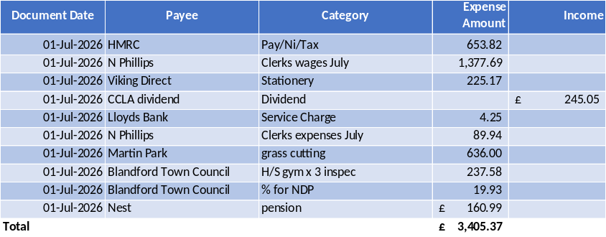

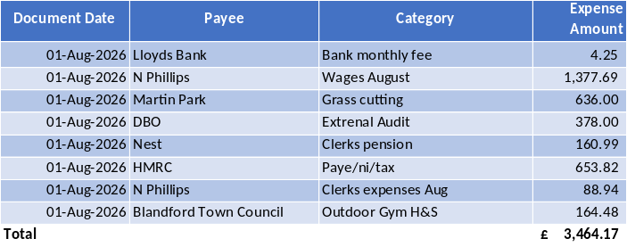

RESOLVED: to pay the invoices on the payment schedule for August for the sum of £3464.17 (36/26 – Current Account)
The bank reconciliation was also approved.

37/26. Received report from Dorset Councillor B Cooper
Cllr Cooper reported the following:
- Has spoken attended a meeting where Dorset Council where present, to discuss how to improve the safety of pedestrians and traffic around Blandford Town and Blandford St Mary. Cllr Cooper requested that Dorset Council re-visit the proposal for a crossing outside the Brewery. A survey has been completed, and Cllr Cooper is awaiting an update.
- Has spoken to the relevant people regarding the poor state of the small play area behind the new Brewery development. Cllr Cooper has received assurance that the management team will look into the complaint over the play area and rubbish bin.
- Dorset Council have opened their boundary review for Town and Parishes. Cllr Cooper expressed that he supports Dorset Councils proposal not the one that Central Government is proposing. The boundary review is moving the boundaries for the wards that Dorset Councillors cover. More details can be found using the link below.
- https://www.bing.com/ck/a?!&&p=97d7607fcabd5e2116a86cb01a46a245c976d8ff82d2145effc701359aacb4feJmltdHM9MTc4ODM5MzYwMA&ptn=3&ver=2&hsh=4&fclid=3d0f684e-aa39-69d8-2643-7f87ab5c680c&psq=Dorset+council+boundary+review&u=a1aHR0cHM6Ly93d3cuZG9yc2V0ZWNoby5jby51ay9uZXdzLzI2NTE0OTIyLm5ldy1ib3VuZGFyaWVzLXByb3Bvc2VkLWNvdW5jaWwtd2FyZHMtZG9yc2V0Lw

38/26. Chairmans’ report
Nothing to report.

39/26. Clerk’s report
Nothing to report

40/26. Items for the next agenda and date of the next meeting. Co-option – Village Hall - Boundary review

Signed…………………………………………………………………………………………
Website address http://www.blandfordstmary-pc.org.uk. Should you wish to contact any Councillor please only use this address.Clerk@blandfordstmary-pc.gov.uk.
Date of next meeting The Parish Council meeting will be held on Wednesday 7th of October 2026,
There being no further business, the meeting was closed at 7.32pm

