Blandford St Mary Parish Council
Minutes of the monthly meeting of the Parish Council which will take place at The Brewery Hall in Hall & Woodhouse Visitor Centre, Bournemouth Road, Blandford St Mary
Minutes are not verbatim
Wednesday the 7th of October 2026 at 7pm

Present: Chairman – Cllr I Mackay, Vice Chairman –Cllr J Dallison, Cllr M Dallison, Cllr T Coats, Cllr C Hobbs
In attendance: Mrs N Phillips (Parish Clerk/RFO), There were 7 members of the public present.
Public Consultation- the following matters were raised:
A member of the public reported that there has been antisocial behaviour taking place in the recreation ground next to Pigeon Close. Drugs are being used by people, which was reported and the police attended at dealt with this one incident. Unfortunately, there have been other signs and reported of drug users in the recreation area. The Parish Council confirmed they have no powers to deal with these individuals and if anyone witnesses anything, please do not approach the corporate, but to ring the police on 999 straight away. The Parish Council will be putting another sign up, warning people that the recreation area will be monitored for antisocial behaviour.
A member of the public asked the Parish Council to chase up Dorset Council and Tesco store, regarding placing a rubbish bin near the bus stop near the Tesco roundabout. The Clerk will re-visit this request with the relevant parties.

41/26. To receive and accept apologies of absence, Declaration of interest and Dispensations.
Cllr N Russell sent her apologies.

42/26. Approve minutes of the meeting held on the 2nd of September 2026
The Minutes of meeting, held on the 2nd of September 2026 were proposed by Cllr M Dallison and seconded by Cllr T Coats that the minutes were an arcuate and true record of the meeting, all in favour.
RESOLVED: to approve the minutes of the 2nd of September 2026 (42/26 no budgetary requirements)
43/26. Co-option for new Councillor
Mr Mark Aldis came forward to be considered for co-option as Councillor for Blandford St Mary Parish Council. Cllr I Mackay proposed Mr Mark Aldis is co-opted on as Councillor, this was seconded by Cllr M Dallison, all in favour.
RESOLVED: Mr Mark Aldis is co-opted on as Councillor for Blandford St Mary Parish Council. (43.26 – New Councillor)

44/26. Items agreed to be discussed from the last meeting and matters arising:
Update on Village Hall – Cllr Mark Aldis confirmed that works have commenced on the site for the Village Hall for necessary ground levelling and services works ready for the footings to be laid.
The Clerk asked for the Parish Council to confirm they will be registering the Village Hall as a Charity, as Hammonds need this confirmed to ensure that the correct VAT is applied to their invoices. This was confirmed and Cllr J Dallison will start the process for applying for Chairty Status.
The Clerk confirmed the Hammonds have sent their first invoice for works as agreed on their schedule and that the Clerk has applied for the 106 funds to be released to ensure a swift payment.
Play Area fencing – the Clerk confirmed that the Parish Council has received one quote for repairing/making good the fencing around the play area and was in the process of obtaining additional quote, like to like. The Clerk also confirmed that there are funds still available from the 106 money that had been allocated to the Play Area. Other small items that require maintenance before the winter will be completed by Ministry of Play.
Meadows Footpath – The Clerk confirmed that she had reported the poor state of the footpath to the Rangers at Dorset Council who have acknowledged the complaint.
Other matters arising – the Clerk asked Councillors if they could officially record their support for Blandford Town Councils proposal for a Pump Track that had been tabled earlier in the year. Cllr Mackay proposed that the Parish Council support this proposal, this was seconded by Cllr J Dallison, all in favour
RESOLVED: to record the Parish Councils support for Blanford Town Council proposal for a Pump Track on the Meadows.(44/26 no budgetary provision)

45/26.Planning
P/TRC/2026/04995 – Land at Stour Meadows – various tree works – A question was raised of why the branches have not been chipped and just left in the area that had been cleared for grass cuttings? The Clerk will ask Dorset Council for their response. ACTION - CLERK

46/26. Finance
The Clerk had circulated the payment schedules and bank reconciliation for September 2026. Cllr J Dallison proposed the payment for September to be paid, this was seconded by Cllr C Hobbs, all in favour. The details of the payments will be shown below:

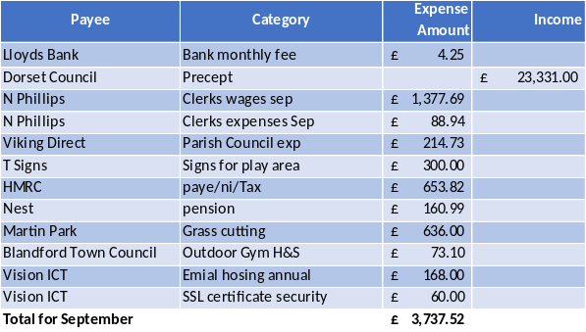
RESOLVED: to pay the invoices on the payment schedule for September for the sum of £3737.52(46/26 – Current Account)
The bank reconciliation was also approved.

47/26. Received report from Dorset Councillor B Cooper
Cllr Cooper reported the following:
- Has once again spoken to the relevant people regarding the poor state of the small play area behind the new Brewery development after receiving another complaint from a local resident.

48/26. Chairmans’ report
Nothing to report.

49/26. Clerk’s report
The clerk confirmed that the grit bins will be filled by Dorset Council.
Correspondence from a cyclist had been circulate, who was expressing his concerns over the poor state of the footpath/cycle way behind the Bellway site to the trial way. It was confirmed that the Parish Council have no powers over the rights of way but will forward his concerns on to the appropriate authorities at Dorset Council.
Correspondence from Dorset Council had been circulated regarding the Dorset Council Local Plan Scoping Consultation. Everyone is encouraged to have a look at their proposal at www.dorsetcouncil.gov.uk/dorset-council-local-plan-consulation . If any members of the public are unable to access the internet, please contact the Clerk for a hard copy of their proposal.

50/26. Items for the next agenda and date of the next meeting. Village Hall – Budget – Officers roles – Fund raising for the Village Hall project

Signed…………………………………………………………………………………………
Website address http://www.blandfordstmary-pc.org.uk. Should you wish to contact any Councillor please only use this address.Clerk@blandfordstmary-pc.gov.uk.
Date of next meeting The Parish Council meeting will be held on Wednesday 4th of November 2026,
There being no further business, the meeting was closed at 7.42pm

